Triangular Dissection

Definition
# Source: AI Source: Provided by: [Data Path: Persons Table -> ID Column: 1, Name_En Column: Motasem Essam] -> From: [ChatGPT] on [7/25/2026]
Triangular Dissection is a geometric dissection method in which a figure is divided into triangular pieces that can be rearranged, joined, or compared to form another figure or to demonstrate a geometric relationship.
Unlike ordinary triangular decomposition, which primarily focuses on dividing a figure into triangles for analysis or area calculation, triangular dissection emphasizes the use of those triangular pieces as components of a dissection. Depending on the problem, the pieces may be rearranged without changing their shapes or sizes.

Simple Definition
# Source: AI Source: Provided by: [Data Path: Persons Table -> ID Column: 1, Name_En Column: Motasem Essam] -> From: [ChatGPT] on [7/25/2026]
Triangular Dissection is cutting or partitioning a geometric figure into triangular pieces that can be used to reconstruct the original figure or form another figure.
For example, a rectangle can be divided along a diagonal into two congruent triangles. Those triangles can then be rearranged to form another shape.
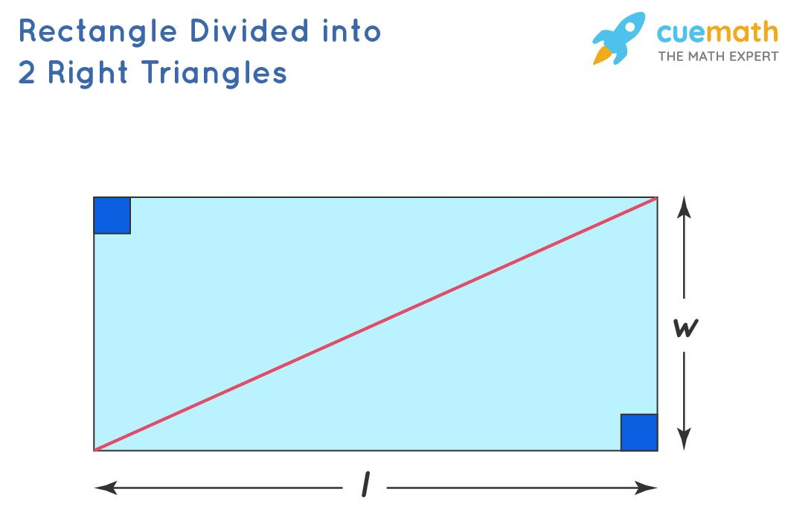
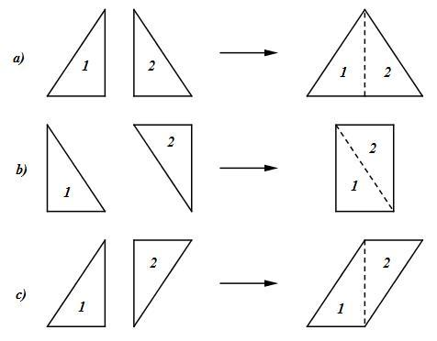
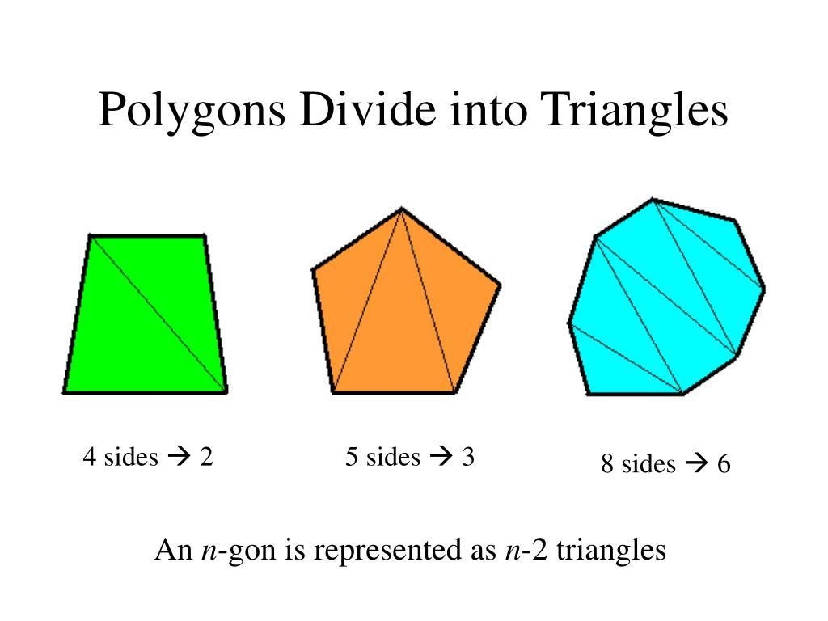

Important distinction:
# Source: AI Source: Provided by: [Data Path: Persons Table -> ID Column: 1, Name_En Column: Motasem Essam] -> From: [ChatGPT] on [7/25/2026]
- Triangular decomposition: emphasizes dividing a figure into triangles.
- Triangular dissection: emphasizes the triangular pieces and how they can be rearranged, compared, or used to form another figure.
The terminology can overlap, and some geometry problems use dissection simply for a partition into pieces, even if no rearrangement is performed.

Main Classification
# Source: AI Source: Provided by: [Data Path: Persons Table -> ID Column: 1, Name_En Column: Motasem Essam] -> From: [ChatGPT] on [7/25/2026]
The following is a practical, descriptive classification, not a universally standardized mathematical taxonomy. Some categories overlap because a single dissection may use several methods.

1. Diagonal-Based Triangular Dissection
# Source: AI Source: Provided by: [Data Path: Persons Table -> ID Column: 1, Name_En Column: Motasem Essam] -> From: [ChatGPT] on [7/25/2026]
Divides a polygon into triangles using one or more diagonals.
Example: cutting a square along a diagonal produces two congruent right-isosceles triangles.
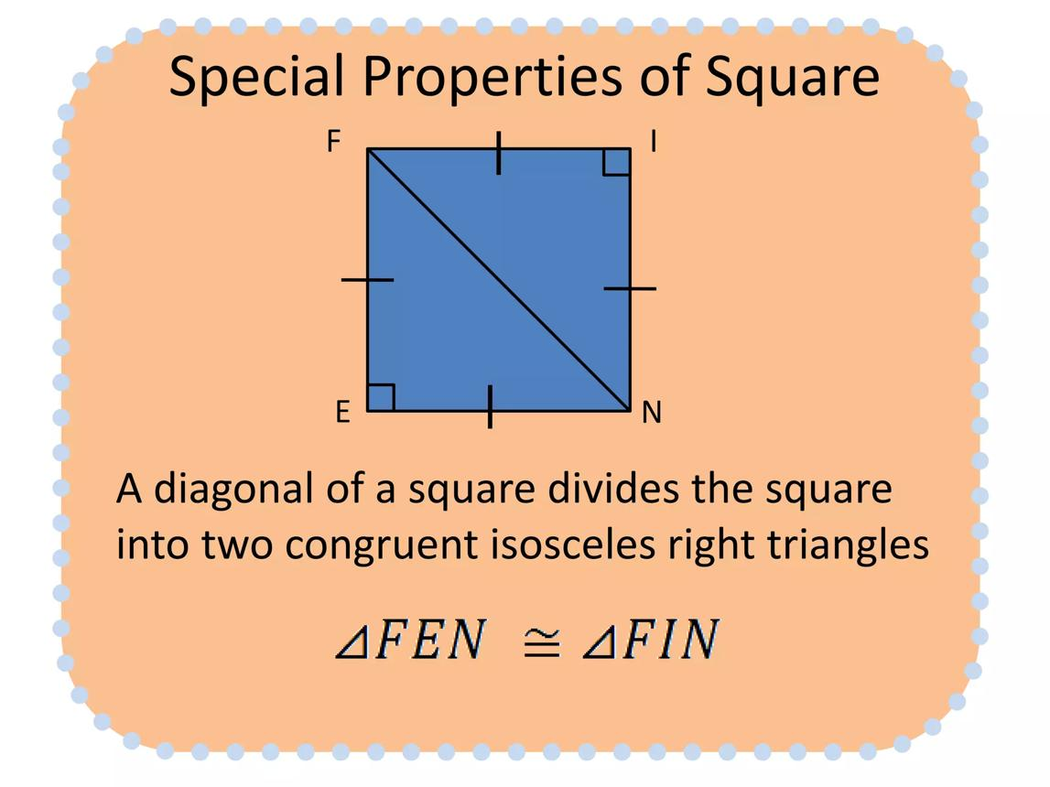
Detailed Explanation and Examples
Definition: A polygon is divided into triangular pieces by drawing diagonals between nonadjacent vertices.
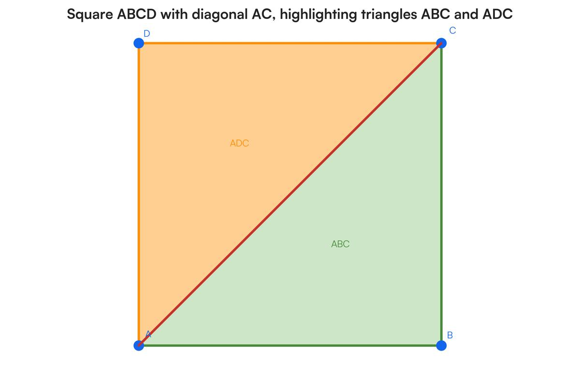
Example: A square has side length $6$ units. A diagonal divides it into two congruent triangles.
The square's area is
$$A=6^{2}=36$$
Each triangle has area
$$A_{△}=\frac{36}{2}=18$$
Each triangular piece has area $18$ square units.
Important: A diagonal joins two nonadjacent vertices of a polygon. For a convex polygon, a diagonal lies inside the polygon and divides it into two smaller polygons.

2. Vertex-Based Triangular Dissection
# Source: AI Source: Provided by: [Data Path: Persons Table -> ID Column: 1, Name_En Column: Motasem Essam] -> From: [ChatGPT] on [7/25/2026]
Connects a selected vertex to other vertices to produce triangular pieces.
Example: dividing a convex pentagon into three triangles from one vertex.
Detailed Explanation and Examples
Definition: A selected vertex is connected to nonadjacent vertices to divide a polygon into triangular pieces.
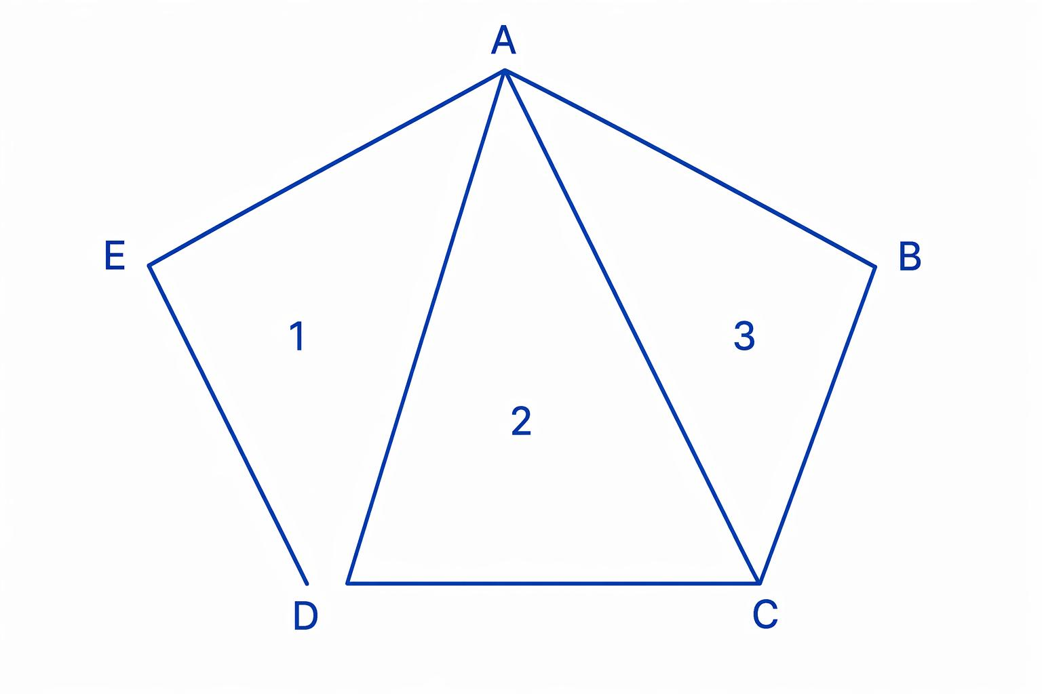
Example: A convex pentagon is divided into triangles by drawing diagonals from one vertex.
The number of triangles produced by this triangulation is
$$T=n-2$$
Since the pentagon has $n=5$ vertices,
$$T=5-2=3$$
If the three triangular pieces have areas $10$, $12$, and $8$ square units, the pentagon's area is
$$A=10+12+8=30$$
Important: For a convex polygon, connecting one vertex to all its nonadjacent vertices creates $n-2$ triangles. The resulting pieces do not have to be congruent or equal in area.

3. Subdivision-Based Triangular Dissection
# Source: AI Source: Provided by: [Data Path: Persons Table -> ID Column: 1, Name_En Column: Motasem Essam] -> From: [ChatGPT] on [7/25/2026]
Divides an existing triangle or polygon into multiple smaller triangular pieces.
Example: dividing a triangle into four smaller triangles using segments parallel to its sides.
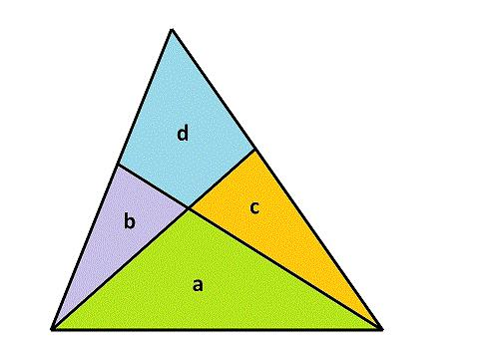
Detailed Explanation and Examples
Definition: A triangle or another polygon is subdivided into smaller triangles using interior line segments.
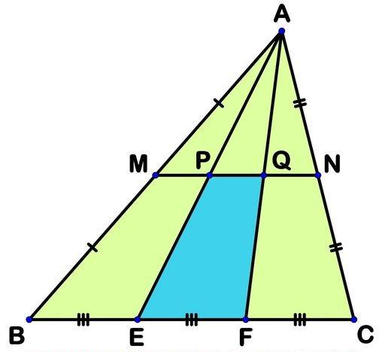
Example: A triangle has base $12$ units and height $8$ units. A segment parallel to its base is drawn halfway up the height.
The original area is
$$A=\frac{12}{\left(12\right)}\left(8\right)=48$$
The smaller top triangle has half the original height and, by similarity, half the original base. Its area is
$$A_{\text{small}}=\frac{12}{\left(6\right)}\left(4\right)=12$$
The remaining lower region has area
$$A_{\text{remaining}}=48-12=36$$
The subdivision creates a small triangle and a trapezoid. To obtain triangular pieces only, the trapezoid can be divided further by a diagonal.
Important: Subdivision does not automatically produce only triangles; additional segments may be needed to triangulate any remaining polygonal regions.

4. Rearrangement-Based Triangular Dissection
# Source: AI Source: Provided by: [Data Path: Persons Table -> ID Column: 1, Name_En Column: Motasem Essam] -> From: [ChatGPT] on [7/25/2026]
Rearranges triangular pieces to construct a different figure without changing the pieces' shapes or sizes.
Example: two congruent right triangles arranged to form a rectangle.
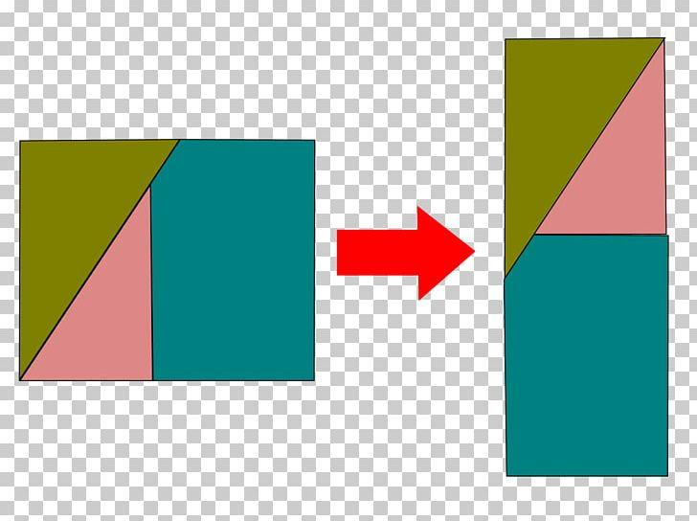
Detailed Explanation and Examples
Definition: Triangular pieces are rearranged to form another figure without changing the pieces' shapes or sizes.
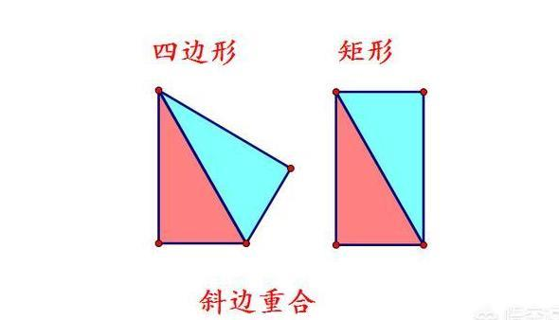
Example: Two congruent right triangles each have perpendicular side lengths $3$ and $4$ units.
The area of each triangle is
$$A_{△}=\frac{12}{\left(3\right)}\left(4\right)=6$$
The total area is
$$A_{\text{total}}=2\left(6\right)=12$$
The two triangles can be arranged as a $3×4$ rectangle, whose area is
$$A_{\text{rectangle}}=3\left(4\right)=12$$
The area is preserved because the same two triangles are used in both arrangements.
Important: A valid rearrangement moves or rotates pieces without stretching, shrinking, or overlapping their interiors.

5. Congruent-Triangle Dissection
# Source: AI Source: Provided by: [Data Path: Persons Table -> ID Column: 1, Name_En Column: Motasem Essam] -> From: [ChatGPT] on [7/25/2026]
Uses triangular pieces that are congruent, meaning they have equal corresponding side lengths and angles.
Example: a square divided by both diagonals into four congruent triangles.
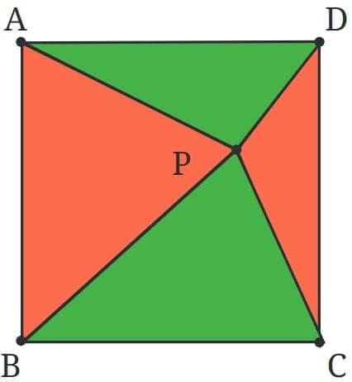
Detailed Explanation and Examples
Definition: A figure is divided into triangular pieces that are congruent, so their corresponding sides and angles are equal.
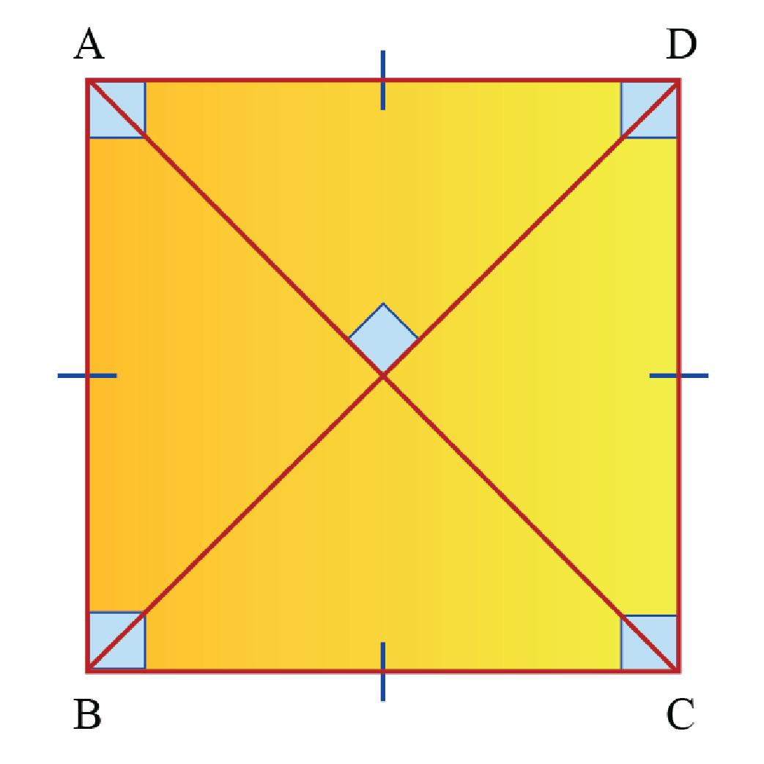
Example: A square has side length $8$ units. Its two diagonals divide it into four congruent triangles.
The total area is
$$A=8^{2}=64$$
Each triangle has area
$$A_{△}=\frac{64}{4}=16$$
Each piece has area $16$ square units.
Important: Congruence guarantees equal areas, but equal area alone does not guarantee congruence.

6. Noncongruent-Triangle Dissection
# Source: AI Source: Provided by: [Data Path: Persons Table -> ID Column: 1, Name_En Column: Motasem Essam] -> From: [ChatGPT] on [7/25/2026]
Uses triangular pieces that may differ in size or shape.
Example: triangulating an irregular pentagon into three triangles of different areas.
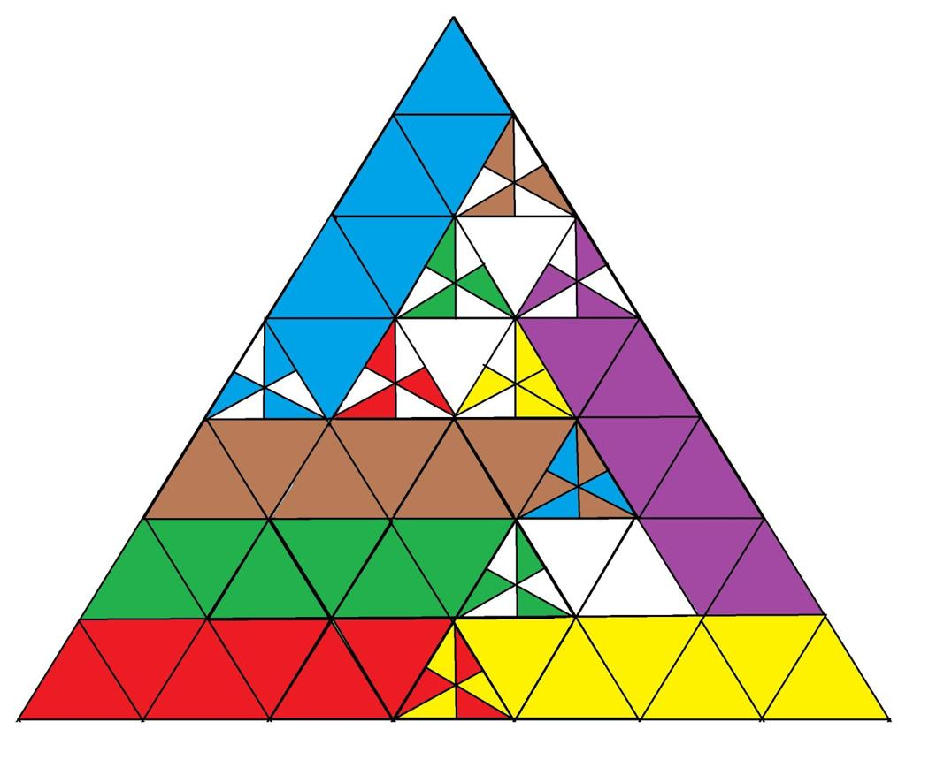
Detailed Explanation and Examples
Definition: A figure is divided into triangular pieces that are not all congruent. The pieces may have different side lengths, angles, and areas.
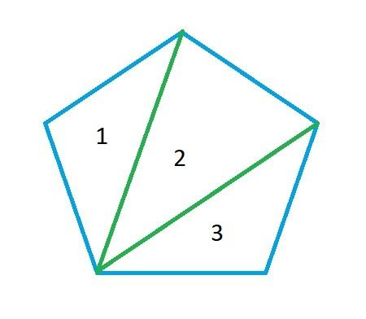
Example: A convex pentagon is triangulated into three triangles with areas $8$, $13$, and $17$ square units.
The total area is
$$A=8+13+17=38$$
The pieces have different areas, so they cannot all be congruent.
Important: Noncongruent triangular pieces can still be rearranged in a valid dissection if each piece is preserved exactly. The resulting figure need not resemble the original.

7. Area-Equivalence Triangular Dissection
# Source: AI Source: Provided by: [Data Path: Persons Table -> ID Column: 1, Name_En Column: Motasem Essam] -> From: [ChatGPT] on [7/25/2026]
Uses triangular pieces to demonstrate that two figures have equal areas.
Example: rearranging the triangles of a square into a rectangle with the same total area.
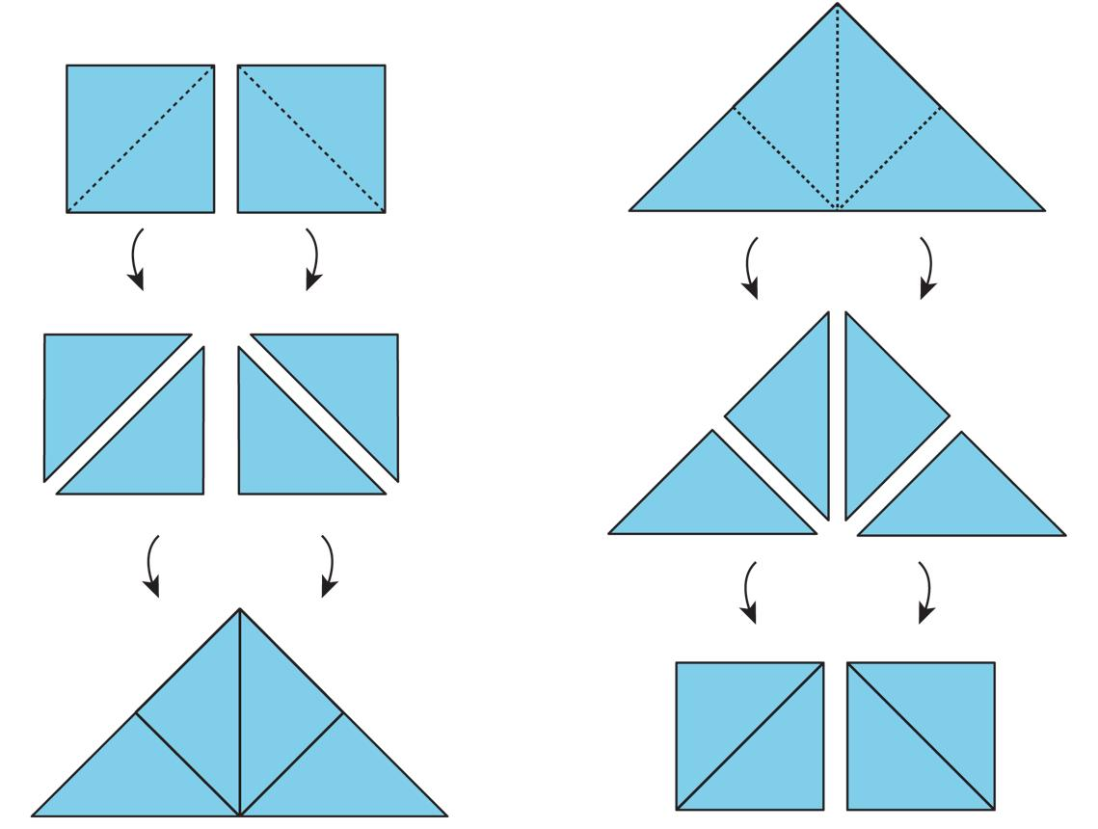
Detailed Explanation and Examples
Definition: Triangular pieces are used to demonstrate that two figures have equal areas, often by rearranging one figure into another.
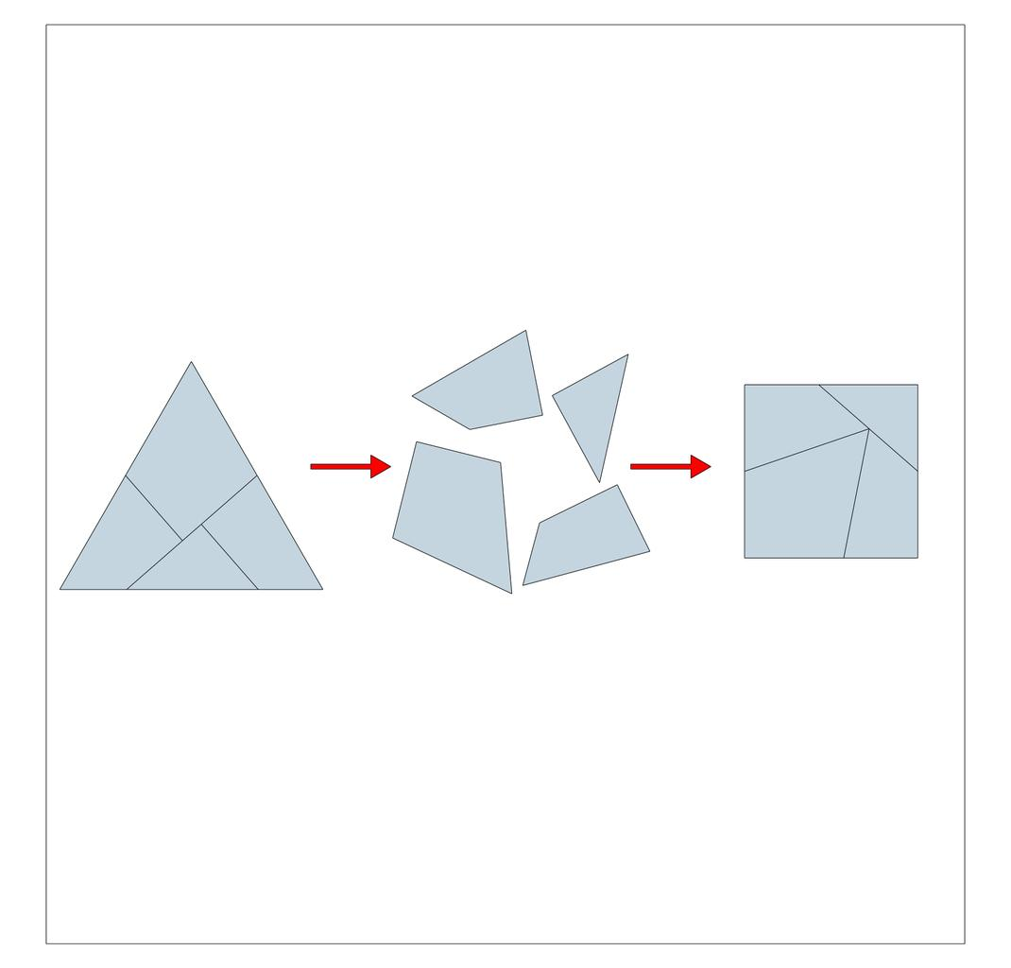
Example: A rectangle has dimensions $8×6$ units. Its diagonal divides it into two triangles, each with area
$$A_{△}=\frac{12}{\left(8\right)}\left(6\right)=24$$
The two pieces together have area
$$A=24+24=48$$
If these exact pieces are rearranged into another non-overlapping figure, that figure also has area $48$ square units.
Important: Area equivalence follows from preserving all pieces and assembling them without gaps or overlapping interiors. Equal-area figures do not necessarily have the same perimeter.

8. Triangle-Based Cross-Figure Dissection
# Source: AI Source: Provided by: [Data Path: Persons Table -> ID Column: 1, Name_En Column: Motasem Essam] -> From: [ChatGPT] on [7/25/2026]
Dissects one figure into triangles that can be assembled into a different type of figure.
Example: triangular pieces from one polygon are rearranged to form a rectangle or parallelogram.
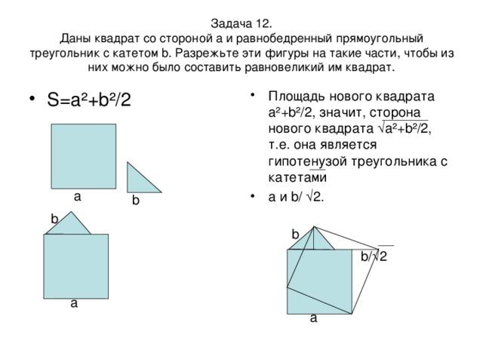
Detailed Explanation and Examples
Definition: One figure is dissected into triangles that can be assembled into a different type of figure.
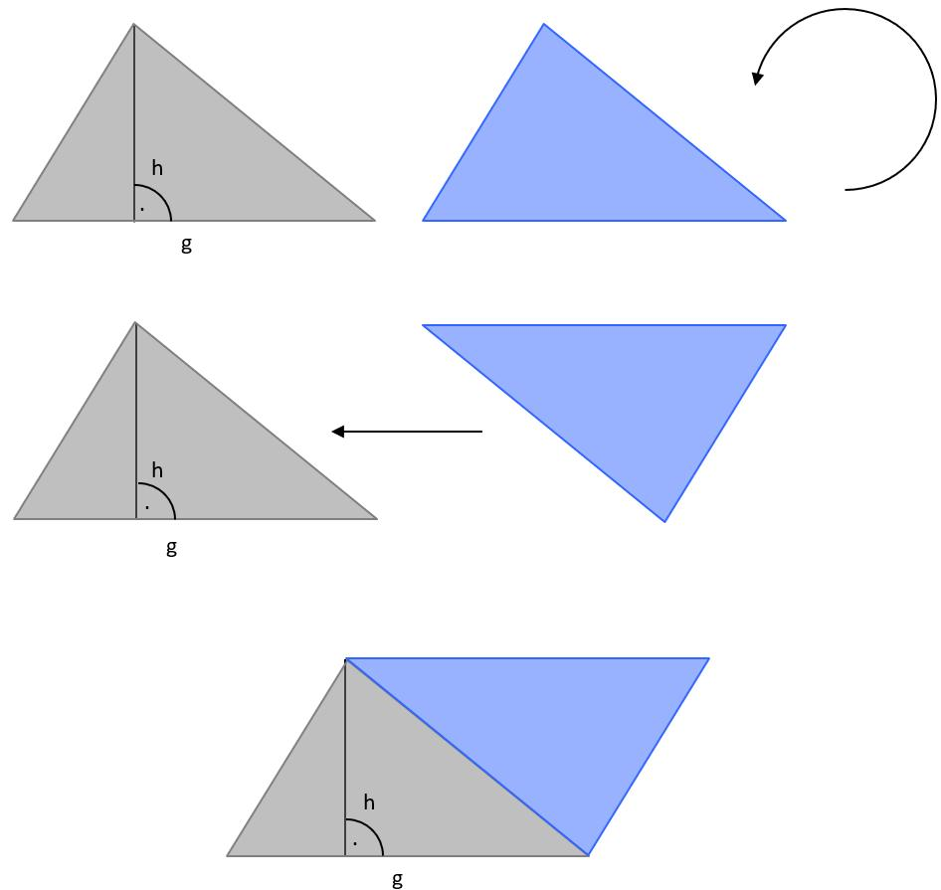
Example: A triangle has base $10$ units and height $6$ units.
Its area is
$$A=\frac{12}{\left(10\right)}\left(6\right)=30$$
The triangle can be subdivided into smaller triangles. If all pieces are rearranged to form a parallelogram with base $10$ units and height $3$ units, the parallelogram's area is
$$A=10\left(3\right)=30$$
Both figures have the same area.
Important: The exact cuts and placement of the pieces must be geometrically valid. Matching areas alone does not prove that a proposed rearrangement can be made from the specified pieces.

9. Median- or Cevian-Based Triangular Dissection
# Source: AI Source: Provided by: [Data Path: Persons Table -> ID Column: 1, Name_En Column: Motasem Essam] -> From: [ChatGPT] on [7/25/2026]
Uses medians or cevians to create triangular pieces within a larger triangle.
Example: three medians divide a triangle into six smaller triangles of equal area.
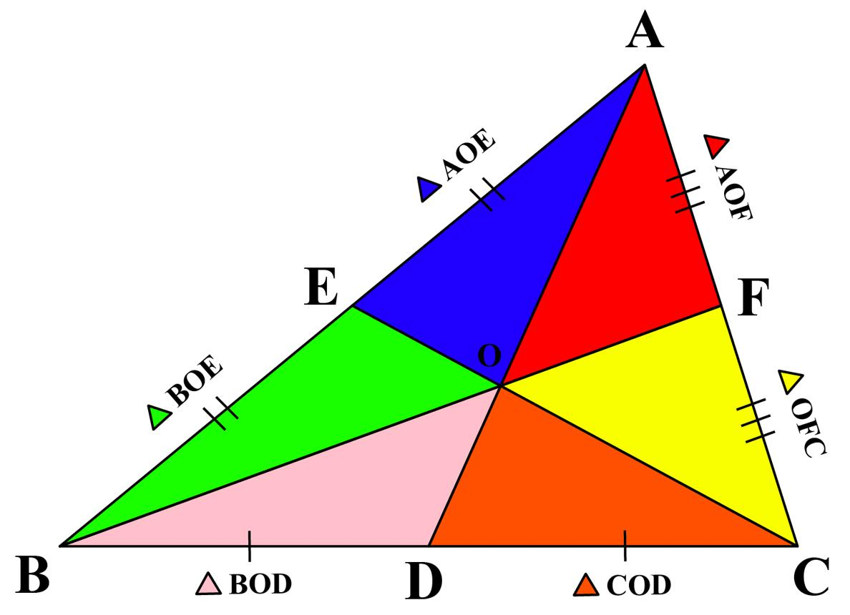
Detailed Explanation and Examples
Definition: Medians or cevians divide a triangle into smaller triangular pieces.
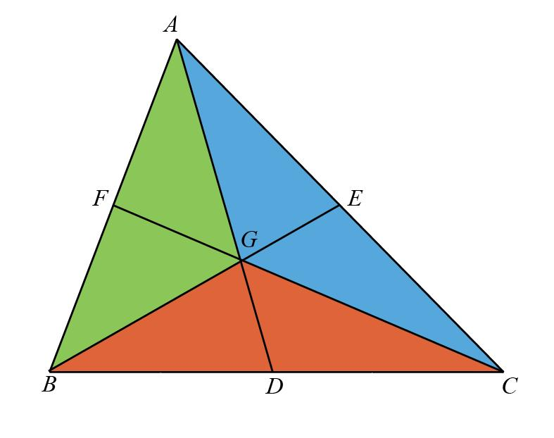
Example: A triangle has area $60$ square units. All three medians are drawn and meet at the centroid.
The medians divide the triangle into six smaller triangles of equal area, so
$$A_{\text{small}}=\frac{60}{6}=10$$
Each of the six triangles has area $10$ square units.
Important: This equal-area result applies to the three medians of a triangle. Three arbitrary cevians do not necessarily divide a triangle into six equal-area regions.

10. Multi-Stage Triangular Dissection
# Source: AI Source: Provided by: [Data Path: Persons Table -> ID Column: 1, Name_En Column: Motasem Essam] -> From: [ChatGPT] on [7/25/2026]
Repeatedly subdivides or rearranges triangular pieces to create increasingly complex dissections.
Example: divide a polygon into triangles, then subdivide selected triangles before rearranging the final pieces.
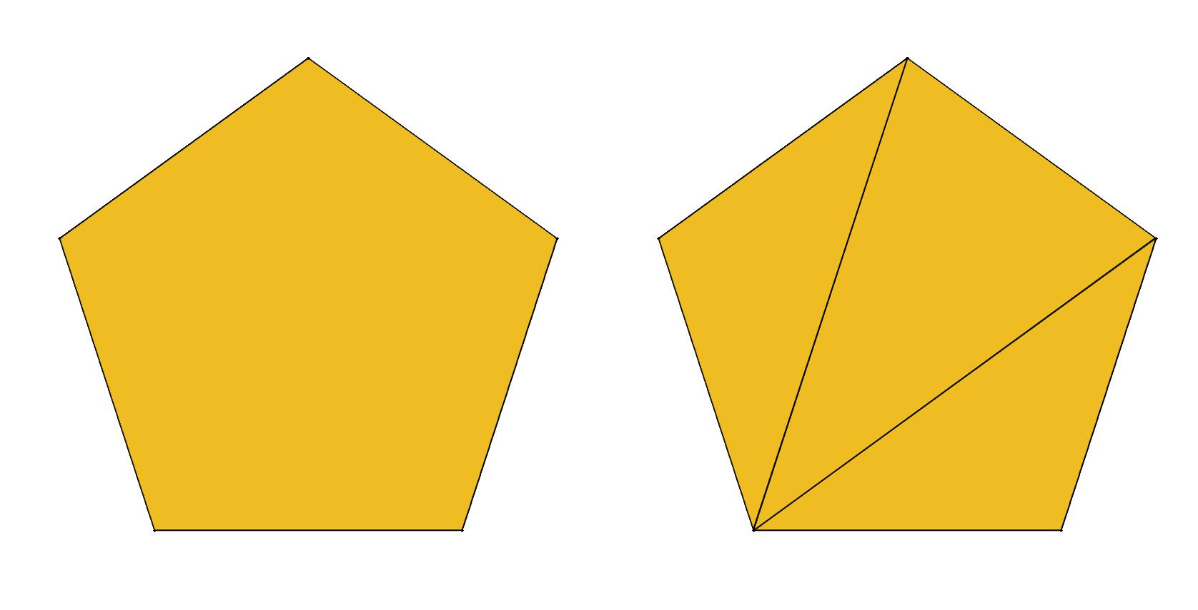
Detailed Explanation and Examples
Definition: A figure is divided into triangles, and selected triangular pieces are subdivided further to produce a more detailed dissection.
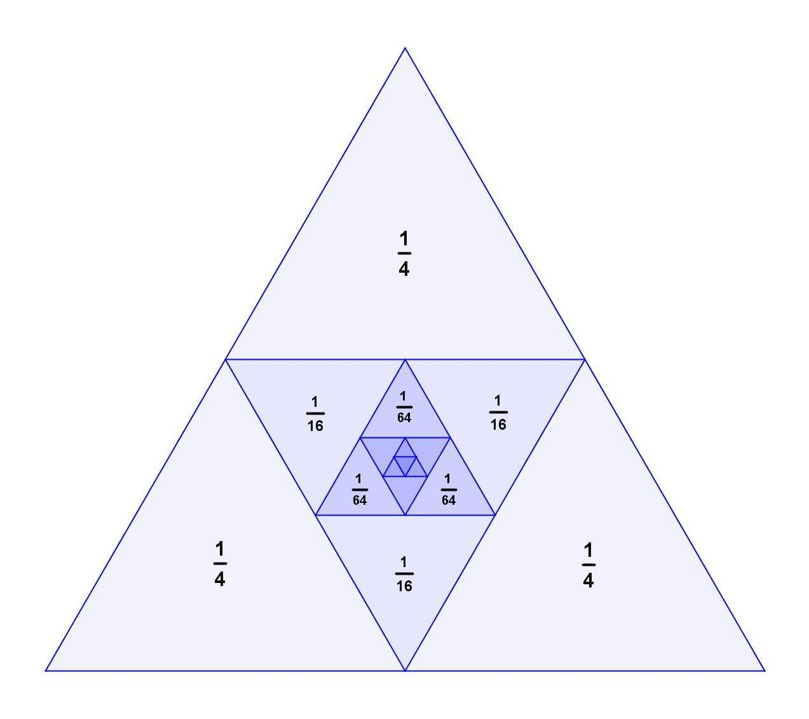
Example: A triangle has area $64$ square units. It is first divided into four equal-area triangles, each of area
$$A_{1}=\frac{64}{4}=16$$
One of those four triangles is then divided into four equal-area triangles. Each new small triangle has area
$$A_{2}=\frac{16}{4}=4$$
The final partition contains three unchanged triangles of area $16$ and four smaller triangles of area $4$.
Verification:
$$3\left(16\right)+4\left(4\right)=48+16=64$$
The total area remains $64$ square units.
Important: Repeated subdivision increases the number of pieces while preserving the total area, provided the pieces cover the original figure without gaps or overlaps.

Key Formulas
# Source: AI Source: Provided by: [Data Path: Persons Table -> ID Column: 1, Name_En Column: Motasem Essam] -> From: [ChatGPT] on [7/25/2026]
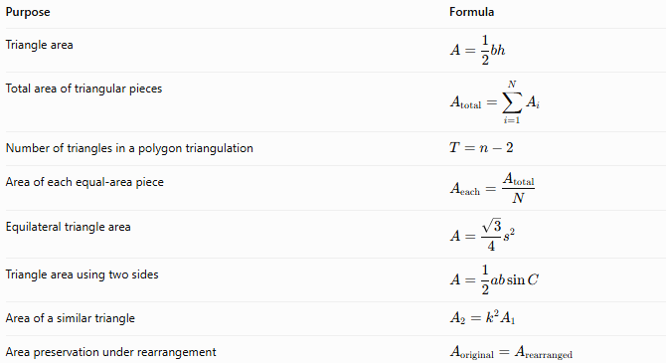
Purpose | Formula
Triangle area | $$A=\frac{1}{2}bh$$
Total area of triangular pieces | $$A_{\text{total}}=\sum_{i=1}^{N}{A_{i}}$$
Number of triangles in a polygon triangulation | $$T=n-2$$
Area of each equal-area piece | $$A_{\text{each}}=\frac{A_{\text{total}}}{N}$$
Equilateral triangle area | $$A=\frac{\sqrt{3}}{4}s^{2}$$
Triangle area using two sides | $$A=\frac{1}{2}ab\sin{C}$$
Area of a similar triangle | $$A_{2}=k^{2}A_{1}$$
Area preservation under rearrangement | $$A_{\text{original}}=A_{\text{rearranged}}$$
Here, $b$ is the base, $h$ is its perpendicular height, $N$ is the number of pieces, $n$ is the number of polygon vertices, $s$ is the side length of an equilateral triangle, and $k$ is a similarity scale factor.

Comparison with Other Dissection Types
# Source: AI Source: Provided by: [Data Path: Persons Table -> ID Column: 1, Name_En Column: Motasem Essam] -> From: [ChatGPT] on [7/25/2026]
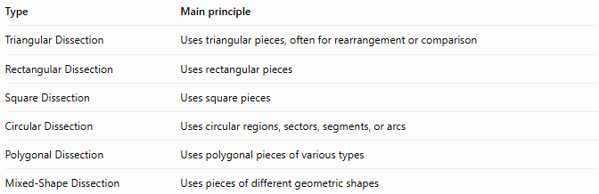
Type | Main principle
Triangular Dissection | Uses triangular pieces, often for rearrangement or comparison
Rectangular Dissection | Uses rectangular pieces
Square Dissection | Uses square pieces
Circular Dissection | Uses circular regions, sectors, segments, or arcs
Polygonal Dissection | Uses polygonal pieces of various types
Mixed-Shape Dissection | Uses pieces of different geometric shapes
Triangular dissection vs. triangular decomposition: Triangular decomposition focuses on dividing a figure into triangles. Triangular dissection places greater emphasis on the resulting pieces and their possible rearrangement or use in demonstrating area equivalence. In some mathematical contexts, the terms overlap.

Classification Summary
# Source: AI Source: Provided by: [Data Path: Persons Table -> ID Column: 1, Name_En Column: Motasem Essam] -> From: [ChatGPT] on [7/25/2026]
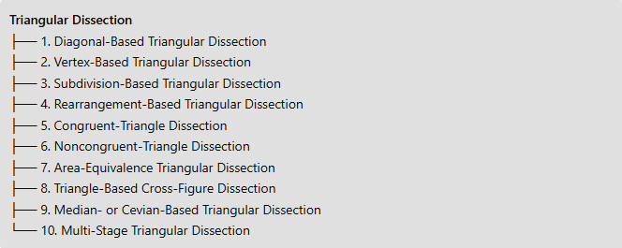
Triangular Dissection
├── 1. Diagonal-Based Triangular Dissection
├── 2. Vertex-Based Triangular Dissection
├── 3. Subdivision-Based Triangular Dissection
├── 4. Rearrangement-Based Triangular Dissection
├── 5. Congruent-Triangle Dissection
├── 6. Noncongruent-Triangle Dissection
├── 7. Area-Equivalence Triangular Dissection
├── 8. Triangle-Based Cross-Figure Dissection
├── 9. Median- or Cevian-Based Triangular Dissection
└── 10. Multi-Stage Triangular Dissection

Key Points
# Source: AI Source: Provided by: [Data Path: Persons Table -> ID Column: 1, Name_En Column: Motasem Essam] -> From: [ChatGPT] on [7/25/2026]
- Triangular dissection uses triangles as the pieces of a geometric dissection.
- Pieces can be congruent or noncongruent and can have equal or unequal areas.
- Rearranging pieces without changing their shapes or sizes preserves their combined area.
- Diagonals, medians, cevians, and triangulation are useful ways to create triangular pieces.
- A valid dissection must cover the intended figure without gaps or overlapping interiors.
- The categories listed here are descriptive and can overlap.

Conclusion
# Source: AI Source: Provided by: [Data Path: Persons Table -> ID Column: 1, Name_En Column: Motasem Essam] -> From: [ChatGPT] on [7/25/2026]
Triangular Dissection is a geometric method that uses triangular pieces to divide, reconstruct, or compare geometric figures. Its practical forms include diagonal-based, vertex-based, rearrangement-based, congruent-triangle, noncongruent-triangle, area-equivalence, and multi-stage dissection. It is particularly useful for geometric puzzles, area proofs, polygon rearrangements, and demonstrating that different figures can have equal areas.

